**Conditional Statements**

Conditional statements are like making decisions in programming. They help your code to behave differently based on certain conditions. The most common type of conditional statement in JavaScript is the "if" statement.

Here's how it works:

Sure, I'd be happy to explain conditional statements in JavaScript in simple terms.

Conditional statements are like making decisions in programming. They help your code to behave differently based on certain conditions. The most common type of conditional statement in JavaScript is the "if" statement.

Here's how it works:

1. **"if" Statement:**

The "if" statement checks a condition. If the condition is true, it executes a block of code. If the condition is false, it skips that block of code.

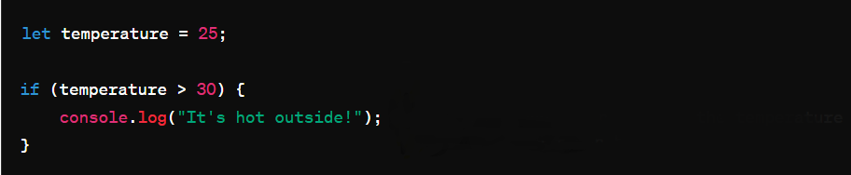

This line won't run because the temperature is not greater than 30.

1. **"If-else" Statement:**

The "if-else" statement checks a condition. If the condition is true, it executes one block of code. If the condition is false, it executes another block of code

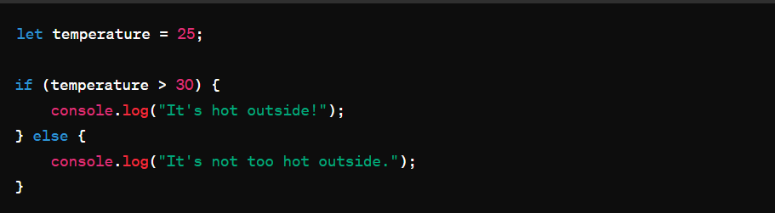

1. **"if-else if-else" Statement:**

This statement allows you to check multiple conditions. It starts with an "if" statement, followed by one or more "else if" statements, and ends with an "else" statement (optional).

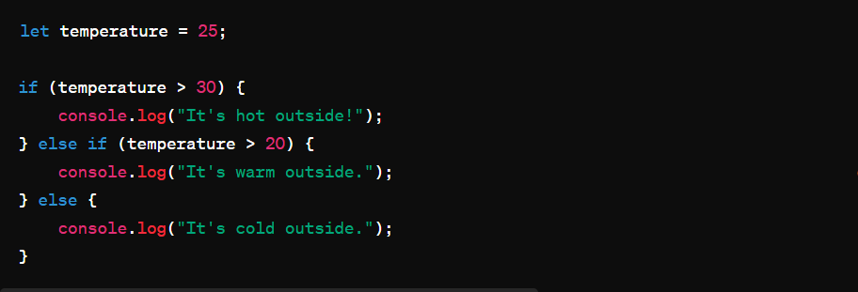

else if (temperature > 20) {

console.log("It's warm outside.");

// This line will be executed because the temperature is greater than 20 but not greater than 30.

1. **Nested Conditional Statements:**

You can also put conditional statements inside other conditional statements. This is called nesting.

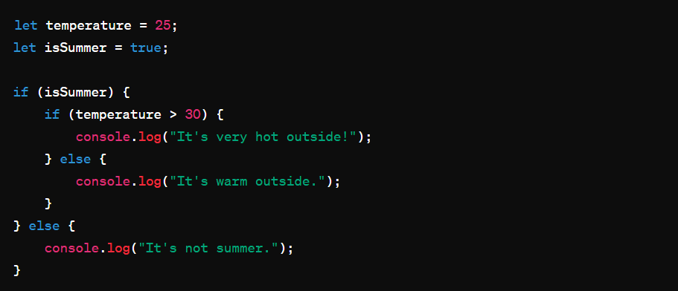

let temperature = 25;

let isSummer = true;

if (isSummer) {

if (temperature > 30) {

console.log("It's very hot outside!");

} else {

console.log("It's warm outside.");

// This line will be executed because it's summer and the temperature is not greater than 30.

}

} else {

console.log("It's not summer.");

// This line won't be executed because the condition isSummer is true.

}

These are the basics of conditional statements in JavaScript. They allow your code to make decisions based on different conditions, making your programs more flexible and powerful.